**Key indicators for Ethiopia CFR assessment**

**ACCESS AND OWNERSHIP**

Individual access to a mobile phone, by status [refugee, IDP etc; host community member]

* No access
* Can borrow
* Owns a basic phone
* Owns a feature phone
* Owns a smartphone

Individual access to an internet-enabled device, by status

* No access
* Can borrow
* Owns

Number of mobile phones in the household, by status

Number of internet-enabled devices in the household, by status

Top three or five barriers to mobile phone ownership, by status

SIM card registration, by status

**Access gaps**

Gender

Individual access to mobile phones, by status and gender

* No access
* Can borrow
* Owns a basic phone
* Owns a feature phone
* Owns a smartphone

Same for Age, disability*, language [any other relevant characteristics]

*\*NB Use Washington Short Set of questions methodology to determine disability*

Individual access to internet-enabled devices, by status, gender, age etc.

* No access
* Can borrow
* Owns

Individual access to internet-enabled devices and location [i.e. do men have access in a more private or more readily accessible locations than women?]

Gender gap / disability gap for mobile ownership

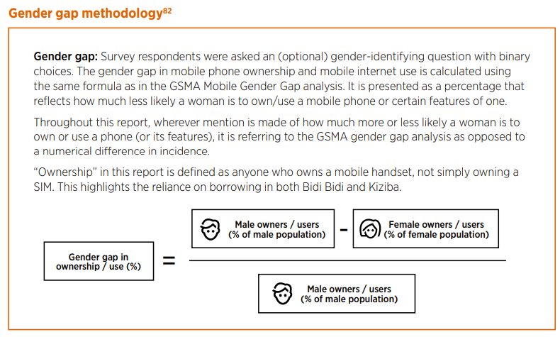

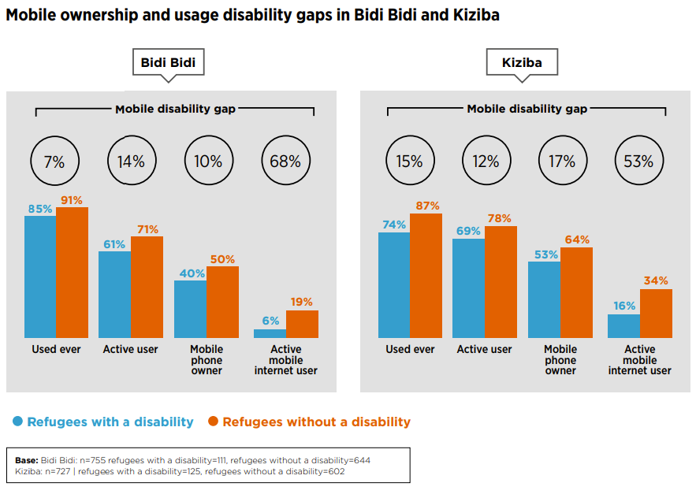

**MOBILE USE CASES AND KNOW HOW**

**Digital literacy and use of services**

Knowledge of mobile services, by status [e.g. make and receive calls, use USSD]

**Use of mobile phones**

Regularity of use

Use of mobile phone services, by status [e.g. Whatsapp, email etc]

Mobile phone use cases, by status [e.g. communicating with friends and family; entertainment etc]

**Use of internet-enabled devices**

Regularity of use

Internet-enabled device use cases, by status [e.g. communicating with friends and family; entertainment etc]

Use cases by gender, including gender gaps [see example below]

**Mobile internet**

Internet awareness and use, by status [% heard of internet / % use internet / % Would like to use mobile internet more]

Gender gap / disability gap for mobile internet use

Barriers to mobile internet use, by status

Barriers limiting internet use, by status

**THE DIGITAL ECOSYSTEM**

**Network availability in key locations**

* % with network coverage at home [for calls/SMS) / % without network coverage at home {for calls/SMS)
* % with mobile internet coverage at home / % without mobile network at home
* % with mobile internet coverage at other key locations [e.g. school, work, community centre etc]
* % with wifi access at home / % without mobile network at home
* % with wifi access at other key locations [e.g. school, work, community centre etc]

**Charging availability in key locations**

* % who can charge phone at home
* % who can charge phone at other key locations [e.g. school, work, community centre etc]
* % who pay a fee to charge phone

**Network availability, by research location**

Merchants and agents

* # of agents surveyed
* Average # of customers served per day
* Most common services provided (e.g. airtime sales, digital literacy support, charging, selling handsets etc)

**Digital humanitarian services**

What role can humanitarian organisations play in providing services digitally, and what role should they play according to end users?

**Concerns about internet use**

What are the most significant concerns shared by the community and are there any intersectional differences?